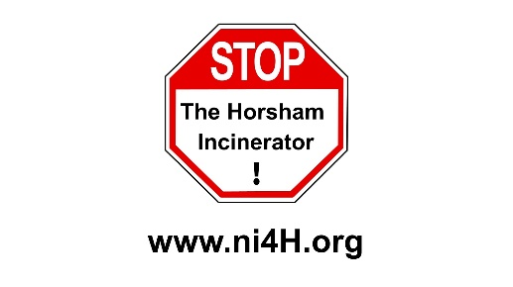
NO INCINERATOR 4 HORSHAM COMMUNITY GROUP

Briefing Paper 29.1.19

Early Day Motion #581 Tabled 22 November 2017
for debate in the House of Commons

MORATORIUM ON NEW WASTE INCINERATION CAPACITY

That this House notes in the UK there is now more waste incineration capacity built and under construction than it is forecast there will be genuinely residual combustible waste to burn; further notes that incineration overcapacity can be a barrier to achieving the recycling society; believes that realising such a recycling society would result in significant economic, social and environmental benefits; acknowledges the need to send a clear message that the waste hierarchy should shift focus away from incineration and towards waste reduction, reuse, recycling and composting; and calls on the Government and the devolved governments to introduce a complete moratorium on new waste incineration capacity, covering both conventional waste incineration and other forms such as gasification and pyrolysis, as a matter of urgency. https://edm.parliament.uk/early-day-motion/51049
The first 6 Members who have signed to support the motion are the sponsors. The primary sponsor is generally the person who tabled the motion and has responsibility for it. Signatures (19)
- Grogan, John, Labour 22 November 2017 Primary Sponsor
- Lucas, Caroline, Green Party
- Davies, Philip, Conservative
- Hodgson, Mrs Sharon, Labour
- Shannon, Jim, Democratic Unionist Party
- Godsiff, Mr Roger, Labour

UPDATE: FROM UNITED KINGDOM WITHOUT INCINERATION NETWORK (UKWIN) 29.1.19

- Early Day Motion 581, which calls for a moratorium on new waste incineration capacity, was signed by 19 MPs including at least one member of every political party active in Westminster.
- In support of the EDM UKWIN produced a number of supporting briefings including:
  - 'Incineration overcapacity' - http://ukwin.org.uk/btb/BtB_Incineration_Overcapacity.pdf
  - 'How incineration harms recycling' - http://ukwin.org.uk/btb/BtB_Incineration_Harms_Recycling.pdf
  - 'How councils can improve their recycling rates' - http://ukwin.org.uk/btb/BtB_How_to_Increase_Recycling.pdf
  - ‘Bin the burners! Removing barriers to a circular economy’
- http://ukwin.org.uk/btb/BtB_Supporting_Info_July_2018.pdf
- Subsequent to the EDM the Government released their Resources and Waste Strategy, which did not include a moratorium on new waste incineration capacity, but which did:
  - Propose measures for separate collection of food waste and garden waste
  - Adopt a 65% recycling target
  - Acknowledge that: "According to our internal analysis...significant additional residual waste energy recovery capacity such as incineration or advanced conversion technologies – above that already operating or planned to 2020 – would not necessarily be needed to meet an ambition of no more than 10%...Tolvik Consulting Ltd. carried out a similar assessment, bringing together existing reports around Energy from Waste, and concluded that there would not be a gap in incineration capacity in 2030, provided the 65% MSW recycling rate ambition was met..."
- UKWIN's report on the adverse climate change impacts of incineration, not only quantified the high climate change cost of incineration, but identified that a significant proportion of what is currently considered 'residual waste' is actually readily recyclable or compostable: http://ukwin.org.uk/climate

FURTHER INFORMATION:

- United Kingdom Without Incineration Network (UKWIN) – happy to answer questions
Website: ukwin.org.uk Email: Shlomo Dowen shlomo.dowen@gmail.com Phone: 01623 640134

- No Incinerator 4 Horsham
Website: ni4h.org Email: NoIncinerator4Horsham@gmail.com

