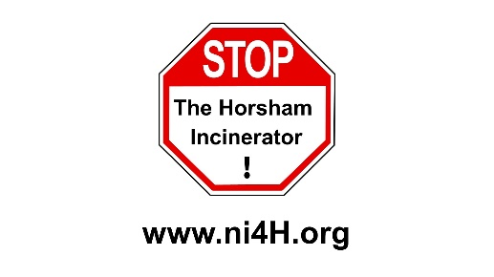
NO INCINERATOR 4 HORSHAM COMMUNITY GROUP

Briefing Paper 2.2.19

R1 RECOVERY STATUS

Operators who want their incinerator to be classed as an energy recovery plant under the Waste (England and Wales) Regulations must apply to the Environment Agency and justify that it is an R1 recovery operation, otherwise by default, it is a disposal activity (D10).

An incinerator that can generate energy with high efficiency can qualify as a waste recovery operation. Incinerator performance is measured using the R1 Energy Efficiency formula, in Annex II of the Waste Framework Directive 2008/98/EC (WfD). The formula calculates energy efficiency as a factor i.e. it is not the same as percentage efficiency.

The R1 formula was designed by the incineration industry. It flatters the efficiency of incinerators and it is not difficult for conventional incinerators to achieve. However, gasification facilities are far less likely to meet the R1 threshold of 0.65 (Note: This does not equate to 65% thermal efficiency). Generally speaking, a plant needs to generate energy at an efficiency of around 25.5% to qualify as R1 compliant - see: http://www.isonomia.co.uk/?p=3501

The significance of R1 status relates both to the eligibility to receive some subsidies, and to qualify as 'recovery' in the context of the waste hierarchy, as distinct from being classed as a ‘disposal’ operation at the bottom of the waste hierarchy (meaning the facility would not support raising waste management up the waste hierarchy).

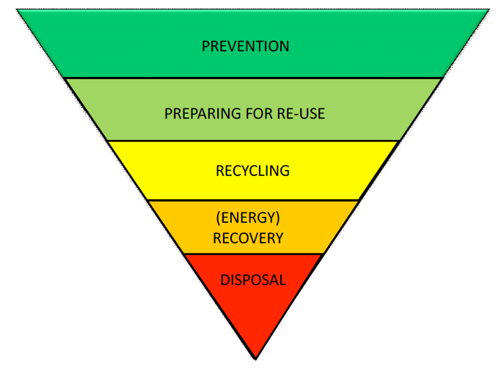
WASTE HIERARCHY:

Most preferred option Refuse / Reduce

Reuse materials

Recycle and reprocess

Energy Recovery prior to disposal

Disposal - landfill and incineration without energy recovery

Least preferred option

GUIDANCE AND INFORMATION:

- EA Guidance: Waste incinerator plant: apply for R1 status
https://www.gov.uk/guidance/waste-incinerator-plant-apply-for-ri-status

- Guidelines on the R1 energy efficiency formula in Annex II of Directive 2008/9/EC http://ec.europa.eu/environment/waste/framework/pdf/guidance.pdf

- Examples of R1 calculations UKWIN carried out for a planning objection
(UKWIN R1 Efficiency Rebuttal of Crummack)

- Environment Agency Letter of clarification (January 2019 EA clarification regarding R1 status)

- List of R1-compliant incinerators: https://ea.sharefile.com/share/view/sb6c8eacefa54ccab

FURTHER INFORMATION:

- United Kingdom Without Incineration Network (UKWIN) – happy to answer questions
Website: ukwin.org.uk Email: Shlomo Dowen shlomo.dowen@gmail.com Phone: 01623 640134

- No Incinerator 4 Horsham
Website: ni4h.org Email: NoIncinerator4Horsham@gmail.com

